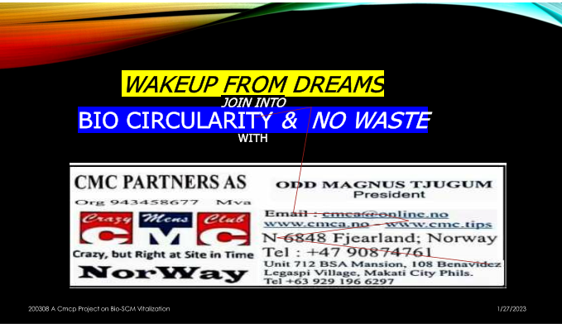

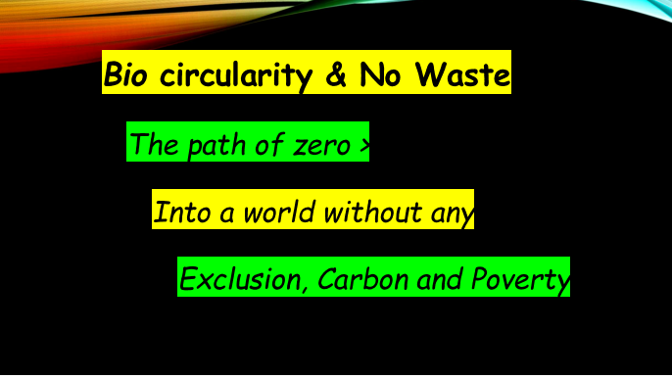

|  |  |
| --- | --- |
|  |  |

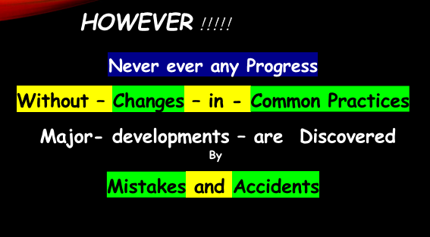

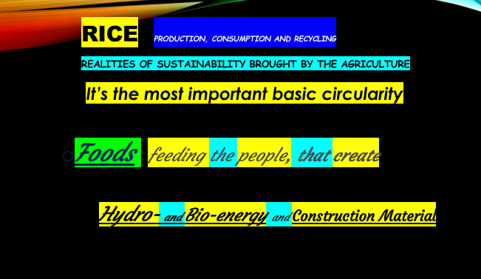

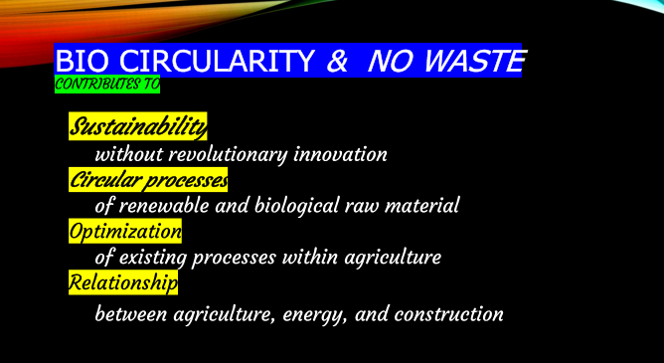

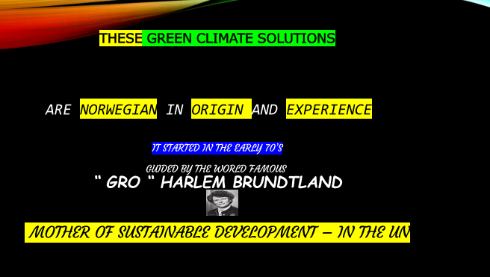

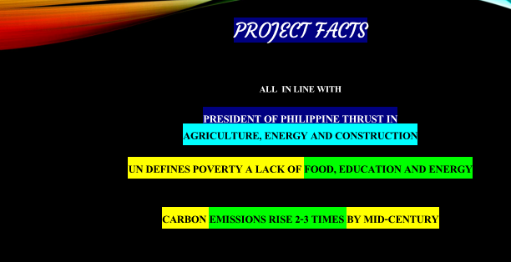

**The Reliable *Path of Zero in Philippine Concrete Structures***

## SINTEF Byggforsk Norway

[harald.justnes@sintef.no](mailto:harald.justnes@sintef.no)

Mobil +47 930 58 688 / <https://www.sintef.no/byggforsk>

The fastest route to make concrete with less CO2 emission is to partly replace the content of cement. The most common Cement Replacement Materials (CRM) are blast furnace slag from iron production, fly ash from coal burning energy plants and Ferro Micro Silica (FMS) from ferro silicon smelters. Common for all these three CRMs are that they are *politically defined* as not being associated with CO2-emission even though they are from heavily polluting industries.

Bio Micro Silica is less common in use but exist in huge quantity, in the countries in Asia. The CO2-emission when burning the Bio-Fuel for energy purpose is *by nature* zero as the same amount of CO2 was drawn from the air by the plants in the first place. This means replacing 20% of any cement in concrete reduces close to 20% of the carbon-footprint of that concrete since the cement is by far the dominating source of CO2-emission (probably > 90% compared to the other constituents like natural aggregate and water).

Depending how effective the Bio Micro Silica is burnt, it may contain a small beneficial fraction of pure carbon. This carbon is then actually taken out of the atmosphere and stored permanently in the concrete. So, replacing cement with Bio Micro Silica will be below zero in terms CO2-emission, **in fact negative**.

Bio Micro Silica has a very high content of amorphous silica with a high surface, rendering it highly potent as an CRM in terms of increased workability, strength and improved durability relative to the cement it replaces. The effect of Bio Micro Silica on concrete properties is well documented in world-wide scientific journal publications and is safe to use.

**References**

Ferro Micro Silica (FMS) is used in many important structures, for instance in the giant oil/gas platform Troll A in the North Sea where 5% FMS of cement mass is used in the concrete recipe.

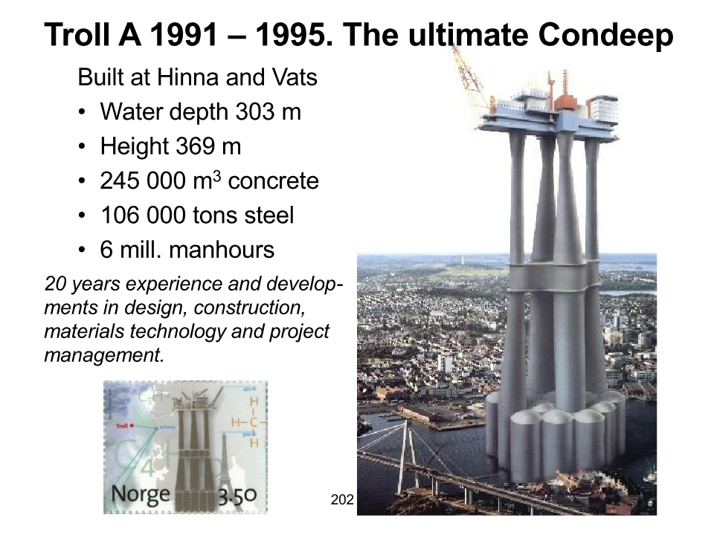

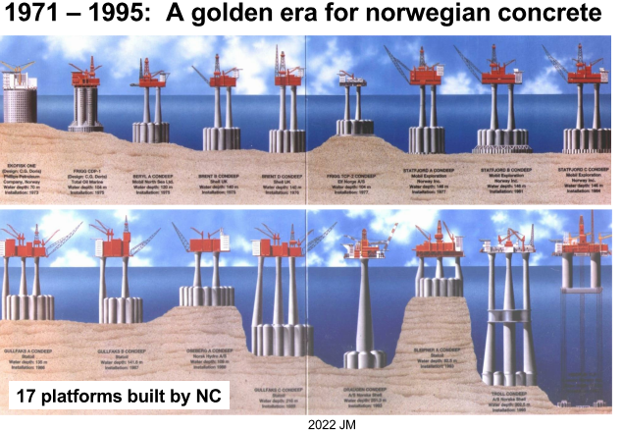

|  |  |  |  |  |  |  |  |  |  |  |  |  |  |  |  |  |  |  |  |  |  |  |  |  |  |  |  |  |  |  |  |  |  |  |  |
| --- | --- | --- | --- | --- | --- | --- | --- | --- | --- | --- | --- | --- | --- | --- | --- | --- | --- | --- | --- | --- | --- | --- | --- | --- | --- | --- | --- | --- | --- | --- | --- | --- | --- | --- | --- |
| [Besøk vår hjemmeside!](https://www.nyeveier.no/) | |  | | --- | | **HARTMUTH WESTBY​​** | | |  | | --- | | **Senior kvalitetsrådgiver** | | | |  |  |  |  |  |  | | --- | --- | --- | --- | --- | --- | | |  |  |  |  |  | | --- | --- | --- | --- | --- | | |  |  |  |  | | --- | --- | --- | --- | | [+47 974 89 291](tel:+47%20974%2089%20291" \t "_blank) | |  | | --- | | **|** | | [Hartmuth.westby@nyeveier.no](mailto:Hartmuth.westby@nyeveier.no" \t "_blank) | | | | | |  |  |  |  |  |  |  |  |  |  |  | | --- | --- | --- | --- | --- | --- | --- | --- | --- | --- | --- | | Nye Veier AS | |  | | --- | | **|** | | |  | | --- | | Vangsvegen 73 | | |  | | --- | | **|** | | |  | | --- | | 2317 | | |  | | --- | | Hamar | | | | |  |  |  |  |  |  |  |  |  |  |  | | --- | --- | --- | --- | --- | --- | --- | --- | --- | --- | --- | | |  |  |  |  |  |  |  |  |  |  | | --- | --- | --- | --- | --- | --- | --- | --- | --- | --- | | |  | | --- | | [Facebook](https://www.facebook.com/nyeveiermjosregionen/) | | |  | | --- | | [Twitter](https://twitter.com/nye_veier) | | |  | | --- | | [YouTube](https://www.youtube.com/channel/UChZx5GDtrNMHuH8DuAx9UaA) | | |  | | --- | | [Instagram](https://www.instagram.com/nyeveier/) | | |  | | --- | |  | | | | |

Here is a reliable information on the topic of FeM-Silica (Ferro Micro Silica) which confirm that FeM-Silica is used in a broad spectre of concrete types, due to the good effect on workability, mechanical strength, durability.

Norwegian road authority (Statens Vegvesen) now described that all new Norwegian Bridges shall have a content between 3 – 10 % by the weight of cement in the mixes.

All SCC (self compacting concrete) made in Norway contain micro silica, due to the good effect of holding aggregates in the fresh matrix, combined securing increased mechanical strength, durability, and less porosity. Likewise, close to all concrete we use in Nye Veier AS contain FeM-Silica.

|  |
| --- |
| Even in Danmark, during my time as concrete engineer at Øresund Tunnel Contractors, all tunnel concrete contain FeM-Silica. |
|  |

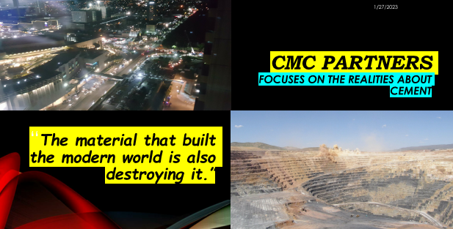



**Tom Melbye**  **|**  Senior Advisor **Normet International Ltd.**  
Rothusstrasse 21   **|**   6331 Hünenberg   **|**   Switzerlan**|**  Mobile +41 79 449 8555  
[tom.melbye@normet.com](mailto:tom.melbye@normet.com)  **|**  [www.normet.com](https://www.normet.com)

Some info and references for use of FeM-silica in shotcrete for some big important projects

FeM-silica is very widely used in most of the big tunnel and Under Ground projects world wide. We estimate that approx 12-14Mio m3/year is sprayed in UG projects ww and 40% of this is with use of m FeM-silica in the mixes .Typical dosage is 5% of cement weight.

A few important projects ww where microsilica was used :

* Gotthard railway tunnel in Switzerland -used for all sprayed concrete , normal concrete and tunnel segments
* Crossrail UK - used in all sprayed concrete and in Uk used in sprayed concrete in all n tunnel projects in London and around London last 20 years
* West and North Connex projects in Sydney ,Australia
* Kiruna mine ,Sweden 250.000 m3/year with sprayed concrete with microsilica

Other projects references for use of FeM-silica in sprayed concrete see in my sprayed concrete book pages 59,61,64,66,67,69,70,71,76,80,81 and 108.

|  |
| --- |
|  |

**BioM-silica means Sustainability**

## Magne Sollie - Norway

004790591594 / [masolli@online.no](mailto:masolli@online.no)

<http://solliesolution.no>

Sustainability is to secure today's needs without destroying the possibilities for future generations to have their needs met."

During the industrial revolution until today, most people's needs have increased in line with technical development, done by the current, old generation. This mostly, by refining the resources in ways that they become more accessible and beneficial to humanity. This happened in overall communities i.e. food, energy, building materials, quality of life etc.

Sorry to say, developments of today goes in the direction of exploiting the resources for personal and political gains with a short time horizon, especially within Energy, Oil production and IT. Everyone is pushed to buy the latest model mobile phone, and forced to pay overpriced electricity and fuel. This to satisfy those people who do not stand for real sustainability, but who **use the word (sustainability) to carry out their deeds**.

Losers are "ordinary people", in lack of possibility and power to influence.

The “New Normal”, however, brought extensive changes in focus, fighting a rising level of CO2 in the atmosphere. the most important substance in agriculture, forestry and green growth. Now blamed for the alleged overall climate change destroying the world. **Decarbonation the world**

Production of Portland cement release huge amount of CO2, emissions into the atmosphere, during burning limestone together with quartz and slate, in large rotary kilns, at appox. 1450 degrees Celsius. This process creates clinker granules, which grounded together with gypsum (plaster) ends up as Portland cement.

Limestone is a mass of small petrified, compressed corals and molluscs that lived in the sea many millions of years ago. The major part of limestone are carbon and oxygen, which when heavily heatedpose the limestone into lime and CO2. Therefor the emissions from cement production come mainly from this calcination process (about 60%), the rest comes from the fuel heating the kilns and finally transportation out into the sites.

Producing ordinary Portland Cement releases approximately 1 tonne of CO2 per tonne of clinker if no measures are taken. Around 40 % comes from fuel for burning, grinding etc and 60 % from decarbonisation of limestone to form clinker.

By replacing Portland Cement with Micro Silica / FeM- / BioM- Silica a significant decarbonation in concrete application/construction / final structures will be achieved.

In figures on decarbonisation of concrete structures this Means;

* for every kg of BioM-silica we add, we reduce emissions by 5 kg of CO2 .

In normal concrete that is **70 kg CO2-emmision /1 m3** and **7000 ton CO2-emmision / 100,000 m3** ,

* all like 1,500 cars are CO2- released per year.
* 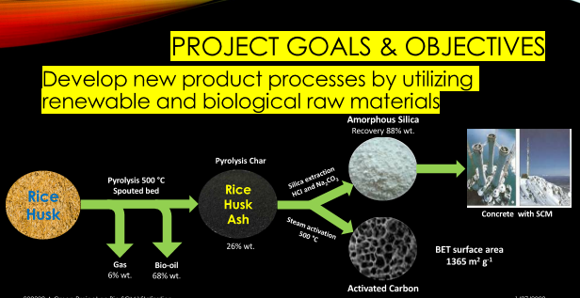
* 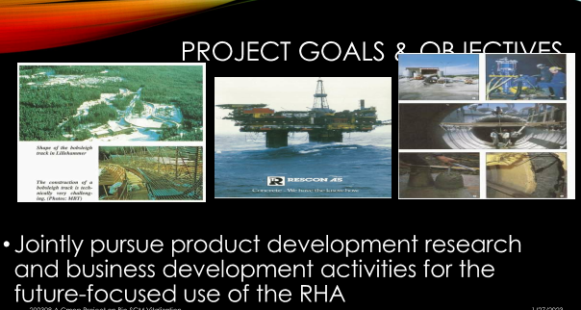
* 

**Philippine Cement- production**

Roberto Caballero, Manila, Construction Materials Consultant

+63 969 181 8804 / [rbrtcaballero@yahoo.com](mailto:rbrtcaballero@yahoo.com)

<https://www.linkedin.com/in/roberto-caballero-0a3b4b14>

The estimated average commercial

price ; PhP 240 per 40 kg bag >r @ PhP 6,000 per ton

quantity; 40Mt (Mt - million tons).

carbon footprint 0.5 ~ 0.6 per 1,000 tons / 20 ~ 24 Mt in the atmosphere.

With the expected rise in cement consumption due to the Build, Build, Build policy of the present administration, the carbon foot prints will proportionally increases.

This is not in line with the COP27 conference late last year in Egypt.

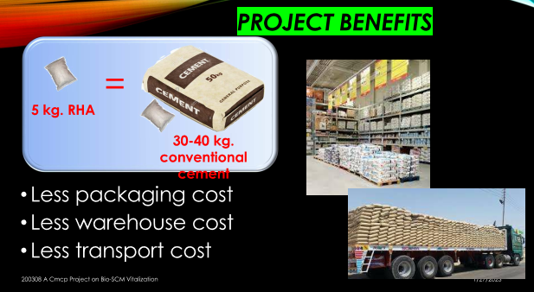

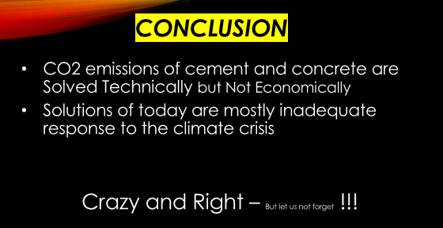

**FeM- /BioM- Silica -**

* **Use, Need and Benefits in the Philippines**

All FeM-Silica used by the construction industry are imported.

The price ; Php 800 per 20 kg bag / @ PhP 40,000 per ton

The extent of use in the construction industry is basically in high compressive strength and high durability concrete mixes.

High rise buildings usually require very high compressive strength concrete mix designs.

Replacing 5 kg of cement **/** 1 kg /**Ferro Micro Silica**, results in a remarkable carbon footprints reduction in the concrete of structures.

**FeM- Silica** are also used during the construction of structure foundations especially where sulphate and chloride are present in the strata.

Should also be used on offshore structures to enhanced durability of concrete against chloride attack. Due to its extreme fineness, **FeM-Silica** replacement (which prevents autogenous cracking) produces very durable concrete structures

**BioM- Silica (mostly adjusted Rice Husk Ash** ) appear as a biproduct, mostly treated and deposited as waste, by Bio power plants, feed / fueled with most, rice husk.

This adjusted ash, **BioM - Silica** has qualities that satisfy international standard for the similar **F**e**M- Silica,** used as additive / replacement to cement in concrete structures worldwide.

* Disposing of untreated **BioM- silica** becomes a serious environmental issue in the nearby communities, problems its use eliminates.

**BioM -Silica** creates major benefits, collected, bagged, labelled and marketed for use in concrete structures, especially those in the Build, Build, Build initiative by the DPWH and DOTr. Its carbon footprints are greatly reduced, structures decarbonized.

* The farmers are getting additional income, more motivated, an overall activity enhancing food production and food security for the humanity community.
* Likewise, marketing is an added revenue for the power plant and the host community. It provid additional income generating employment for the marketing staff and connections.

All reasons and incentives mentioned, the remarkable decarbonizing achieved, make it easy and very beneficial to invest in use of **BioM – Silica.**

